Cloud Computing (Lab 11)
Name : Tooba Shafique
Reg no : 2023-BSE-065
BSE-V-B

Lab 11 – GH CLI Codespaces + AWS + Terraform: Variables, Collections, Sensitivity & EC2 Provisioning
Estimated Duration: 3 hours
Submission: Push all files and screenshots to CC_<YourName>_<YourRollNumber>/Lab11.

Task 0 – Lab Setup (Codespace & GH CLI)
Objective: Create repository, set up Codespace, and connect via SSH.
Screenshots Required:
- taskA_codespace_create_and_list.png – repo creation and Codespace list
- taskA_codespace_ssh_connected.png – terminal inside Codespace after SSH
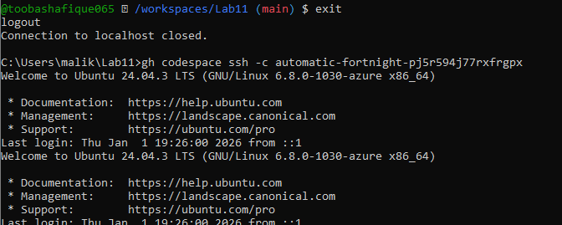

Task 1 – Provider & Basic Variable (Variable Precedence)
Objective: Initialize Terraform, define variables and outputs, and test variable precedence (default, environment variable, terraform.tfvars, -var).
Screenshots Required:
- task1_touch_main_tf.png
- task1_main_tf_provider.png
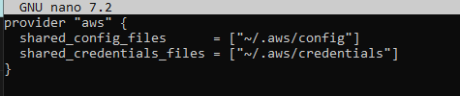
- task1_terraform_init.png
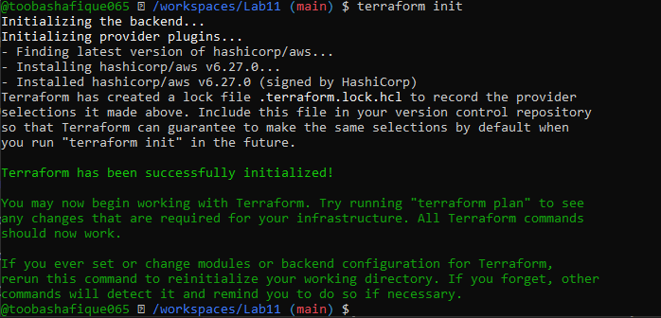
- task1_variable_and_output_added.png
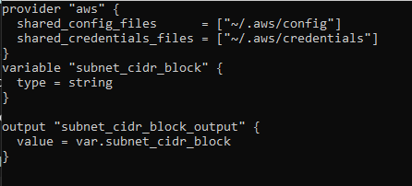
- task1_apply_prompt_for_var.png
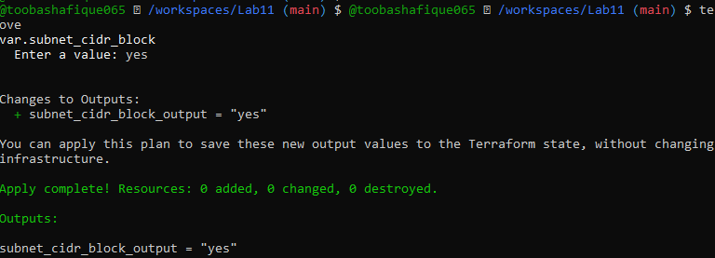
- task1_apply_with_default.png
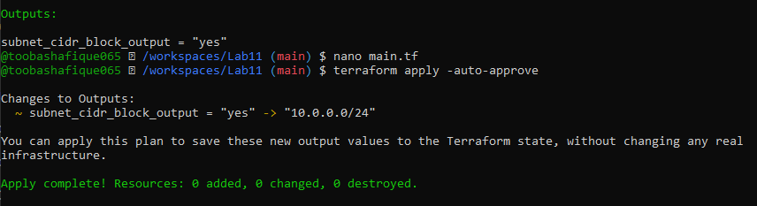
- task1_env_var_set_and_apply.png
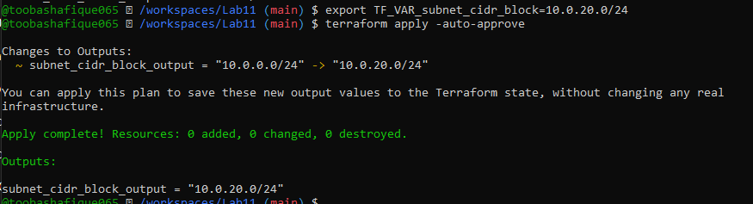
- task1_terraform_tfvars_and_apply.png
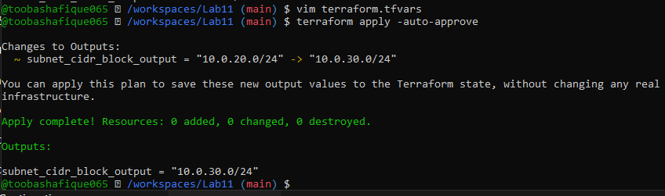
- task1_var_override_with_dash_var.png
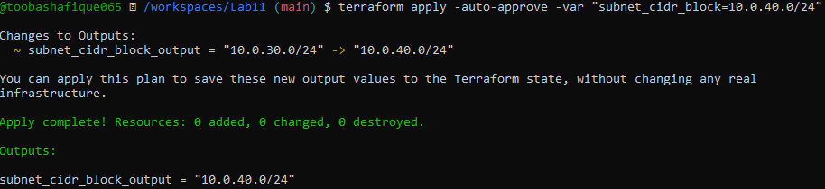
- task1_printenv_tf_var_and_unset.png
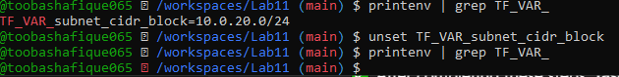

Task 2 – Variable Validation & Sensitive / Ephemeral Variables
Objective: Use variable validation, create sensitive and ephemeral variables, and observe behavior in Terraform state and outputs.
Screenshots Required:
- task2_subnet_variable_with_validation.png
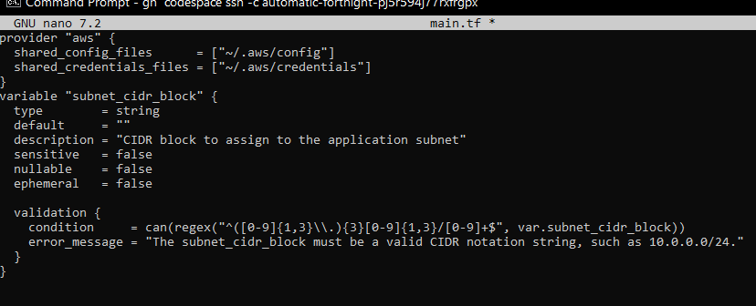
- task2_subnet_validation_error.png
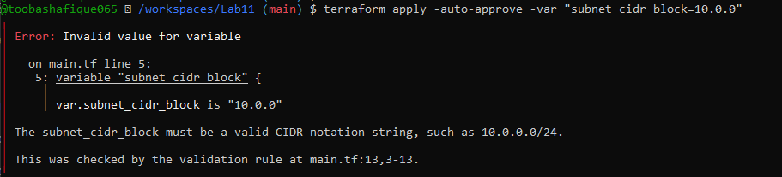
- task2_api_token_variable_added.png
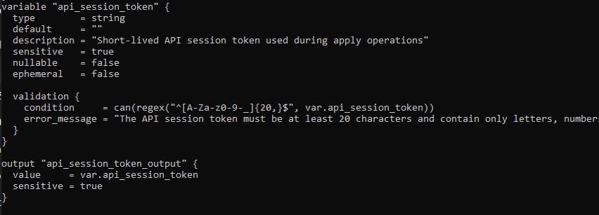
- task2_api_token_apply_sensitive.png
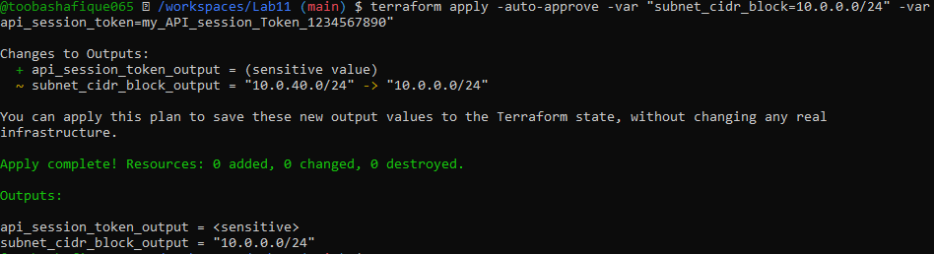
- task2_check_terraform_state_api_token.png
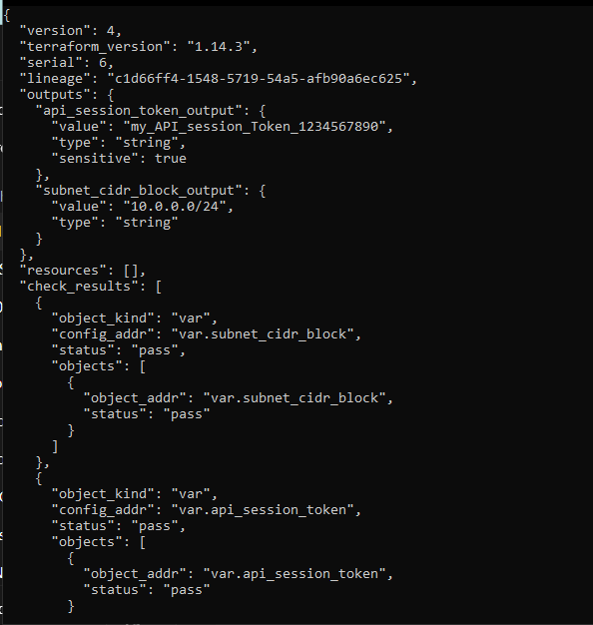
- task2_api_token_ephemeral_error.png
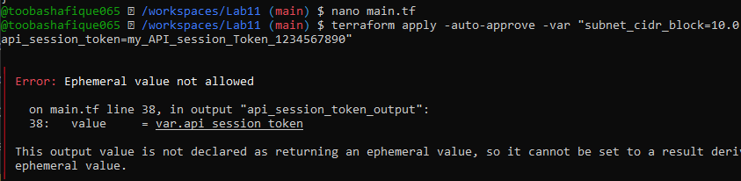
- task2_api_token_default_apply.png
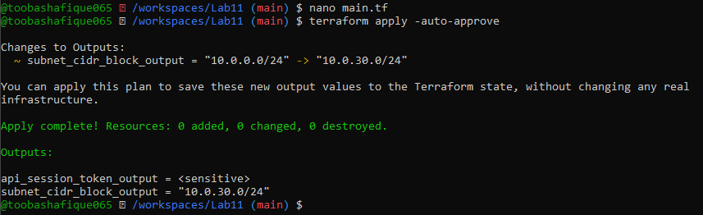

Task 3 – Project-level Variables, Locals, and Outputs
Objective: Define project-level variables, create locals for derived values, and configure outputs to display them.
Screenshots Required:
- task3_variables_added.png
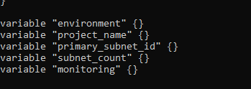
- task3_terraform_tfvars_populated.png
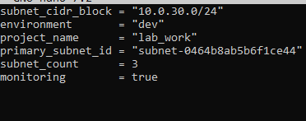
- task3_locals_tf_created.png
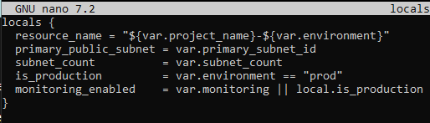
- task3_outputs_apply.png
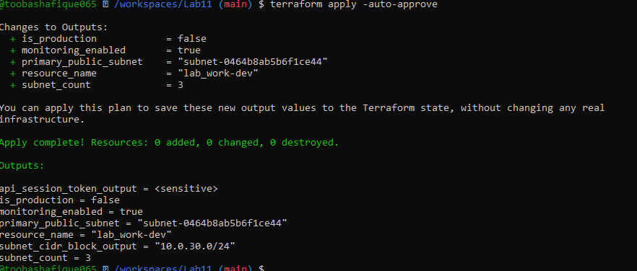

Task 4 – Maps and Objects
Objective: Use map and object variables, populate them in terraform.tfvars, and output the values.
Screenshots Required:
- task4_tags_variable_added.png
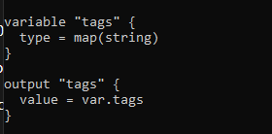
- task4_tags_output.png
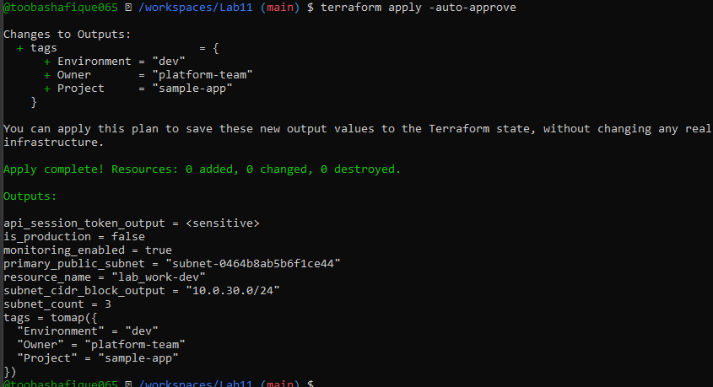
- task4_server_config_output.png
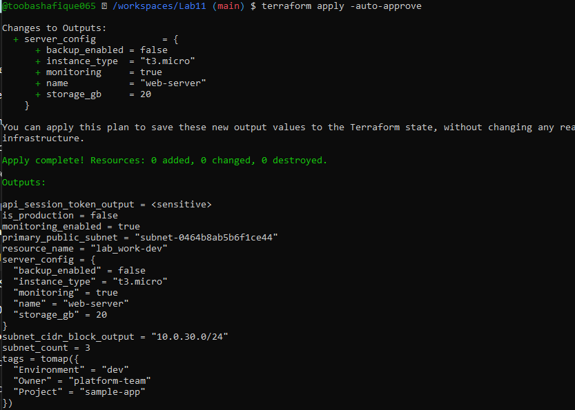

Task 5 – Collections: List, Tuple, Set & Mutation via Locals
Objective: Define list, tuple, and set variables, observe behavior, mutate collections via locals, and compare original vs mutated values.
Screenshots Required:
- task5_collections_defined.png
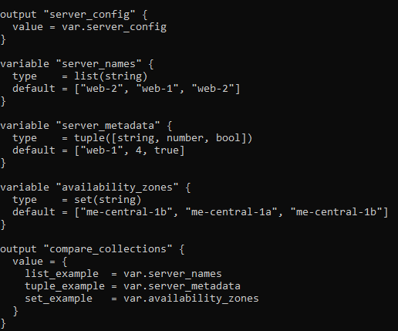
- task5_compare_collections.png
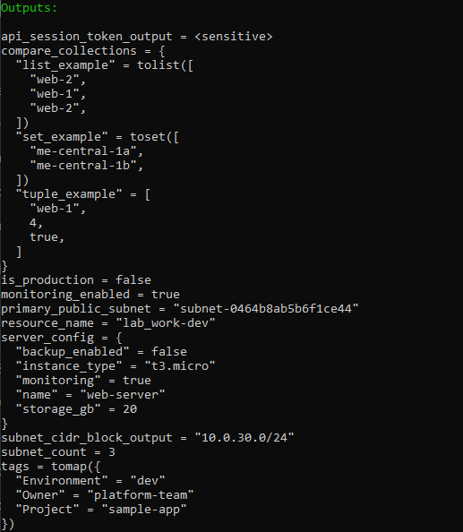
- task5_locals_mutations.png
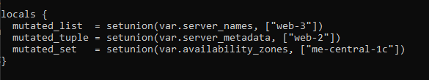
- task5_mutation_comparison.png
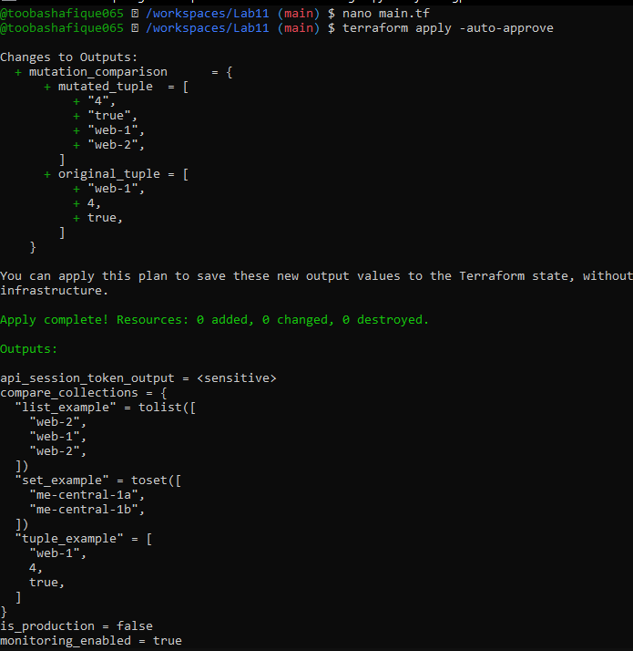

Task 6 – Null, Any Type & Dynamic Values
Objective: Work with null values, dynamic (any) types, and optional tags.
Screenshots Required:
- task6_optional_tag_variable.png
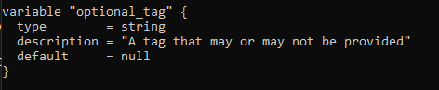
- task6_locals_merge.png
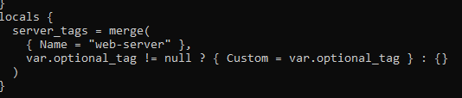
- task6_optional_tag_no_value.png
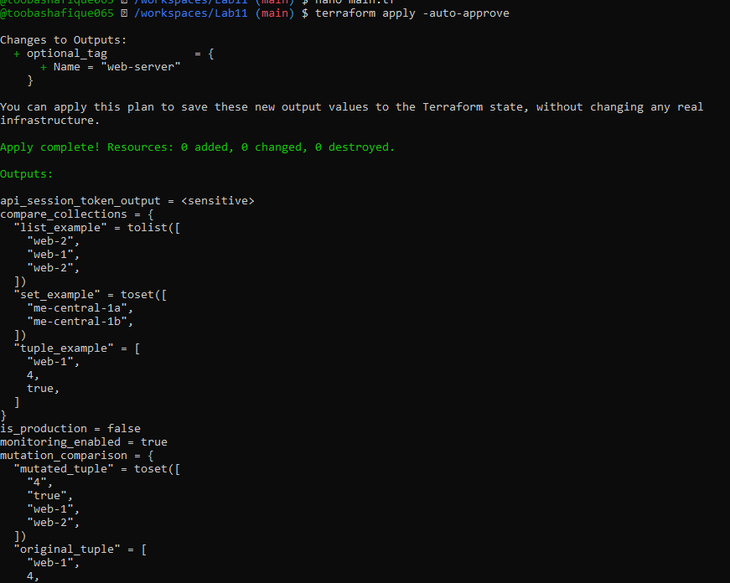
- task6_optional_tag_with_value.png
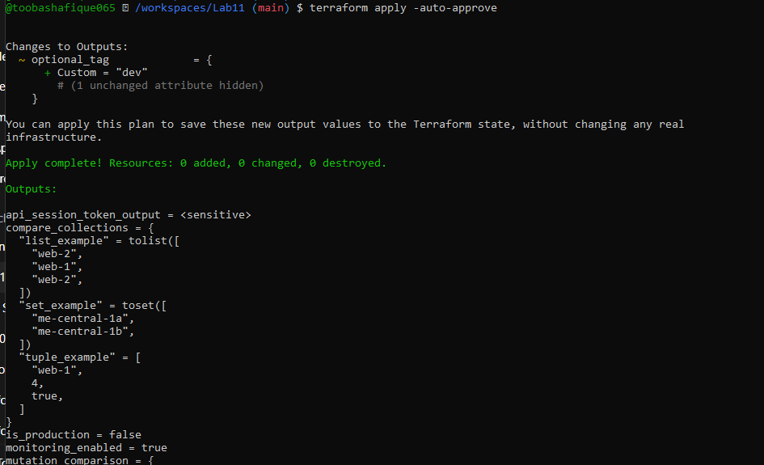
- task6_dynamic_value_string.png
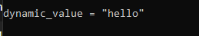
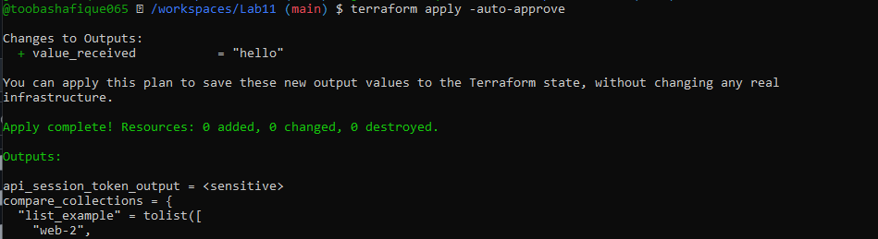
- task6_dynamic_value_number.png
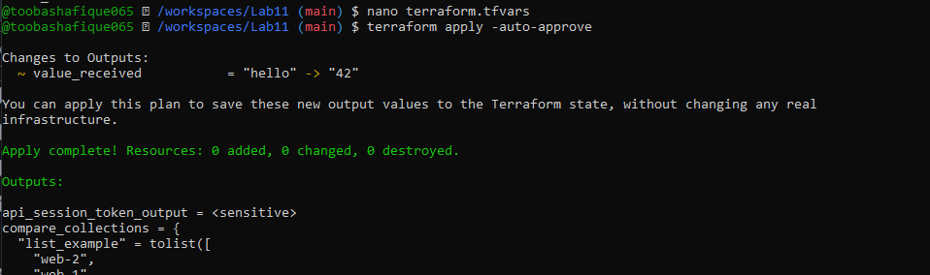
- task6_dynamic_value_list.png
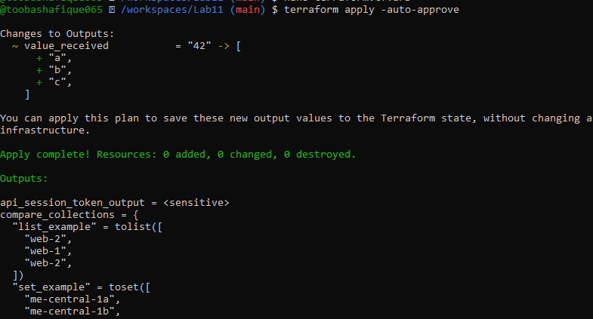
- task6_dynamic_value_map.png
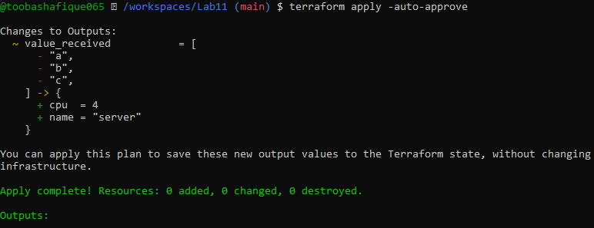
- task6_dynamic_value_null.png
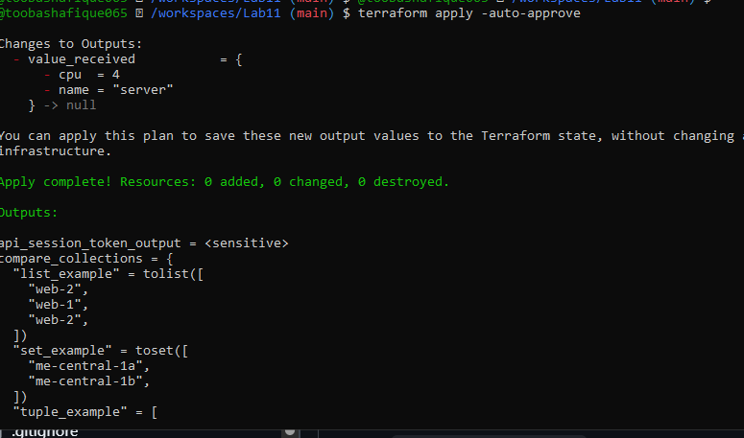

Task 7 – Git Ignore
Objective: Create .gitignore to prevent committing sensitive files like .tfstate, .pem, and credentials.
Screenshots Required:
- task7_gitignore_created.png
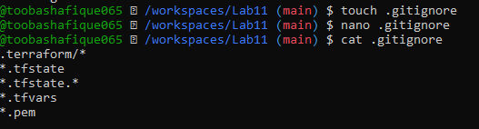

Task 8 – Build Real Infrastructure: VPC, Subnet, IGW, Routing
Objective: Create AWS VPC, Subnet, Internet Gateway, Route Tables (custom and default), and associate them properly.
Screenshots Required:
- task8_clean_files.png
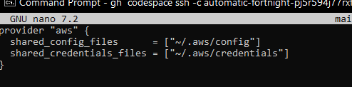
- task8_variables_recreated.png
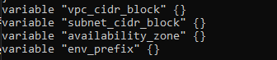
- task8_vpc_resources_added.png
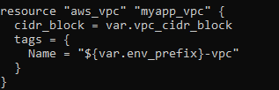
- task8_subnet_resources_added.png
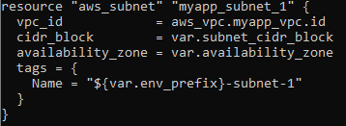
- task8_terraform_tfvars_vpc_values.png
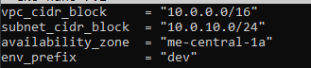
- task8_vpc_subnet_apply.png
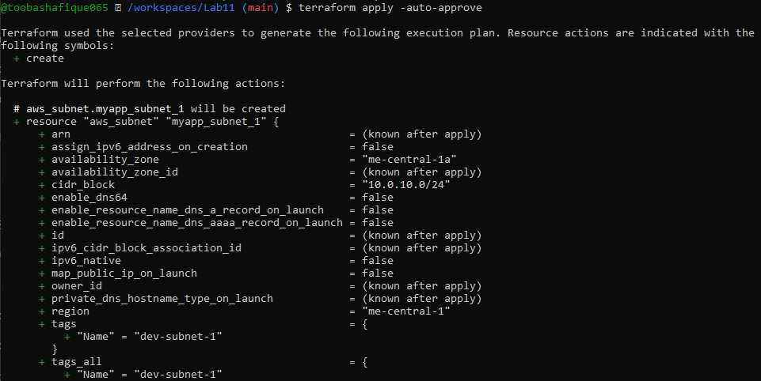
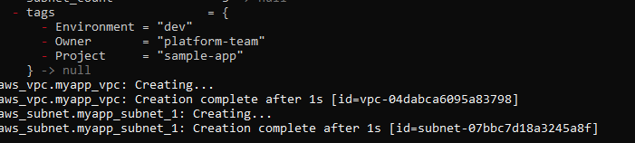
- task8_igw_route_table_before_apply.png
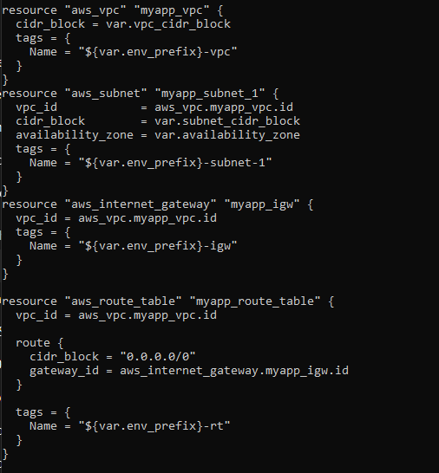
- task8_igw_route_table_after_apply.png
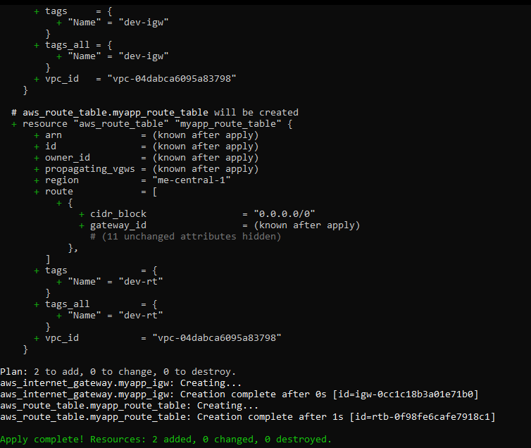
- task8_association_apply.png
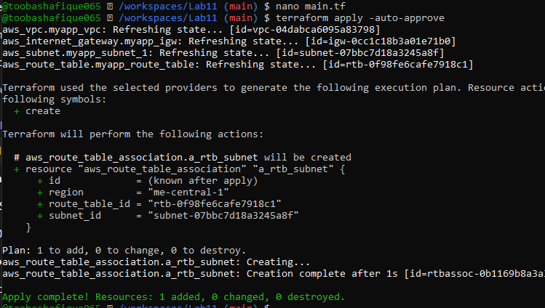
- task8_default_route_table.png
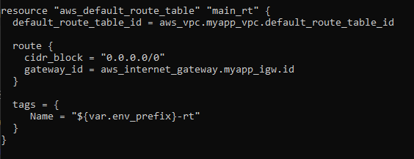
- task8_default_route_table_apply.png
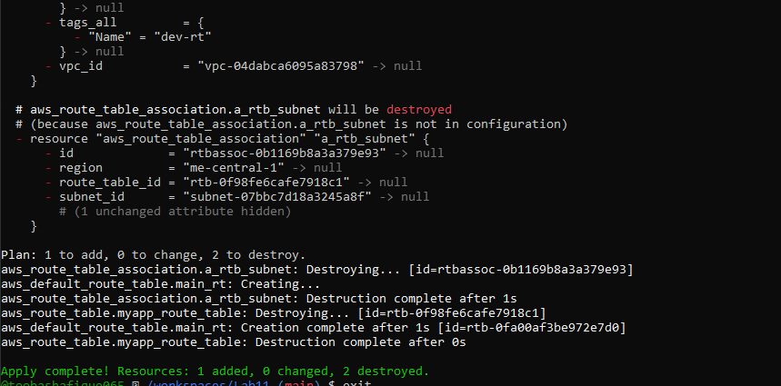
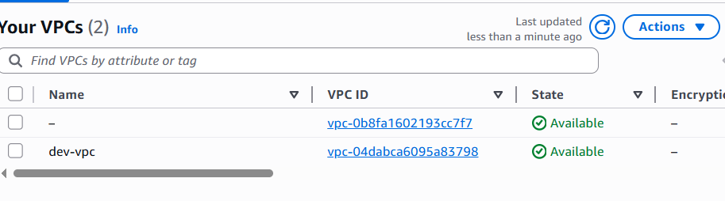

Task 9 – Security Group, Key Pair, EC2 Instance, user_data & Nginx
Objective: Create Security Group, Key Pair, EC2 instance, configure SSH, install nginx via inline and external script user_data.
Screenshots Required:
- task9_my_ip_variable_added.png
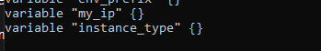
- task9_public_ip_curl.png
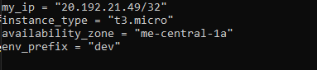
- task9_security_group_apply.png
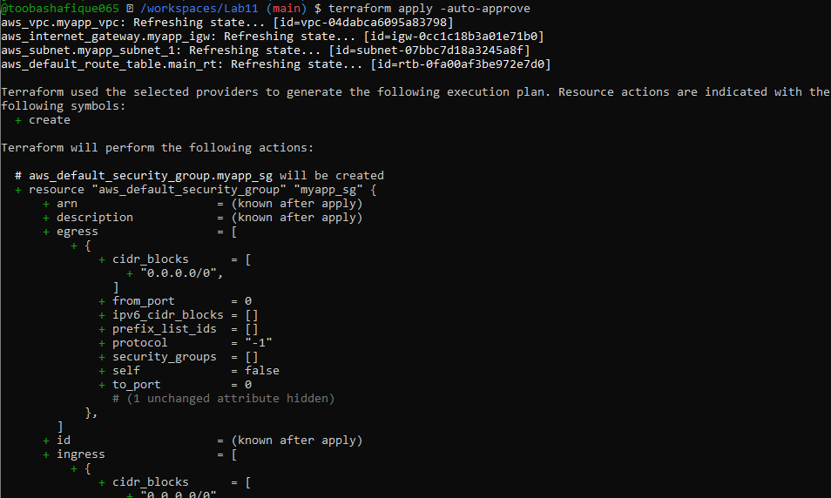
- task9_keypair_created_and_saved.png
- task9_instance_type_set.png
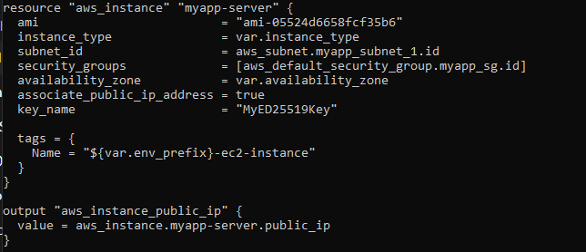
- task9_ec2_apply_and_public_ip.png

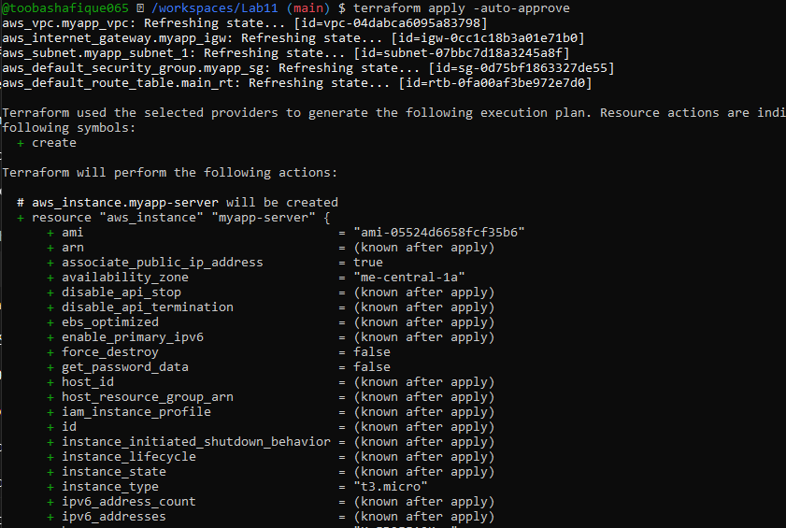
- task9_ssh_into_ec2.png
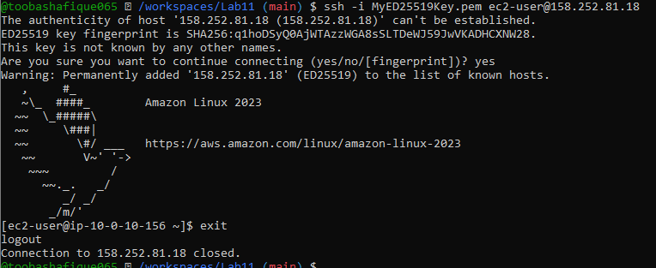
- task9_ssh_keypair_and_ssh.png
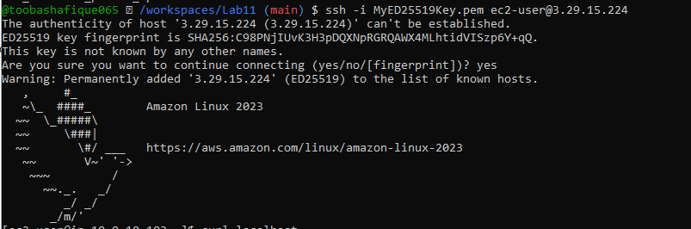
- task9_nginx_local_curl.png
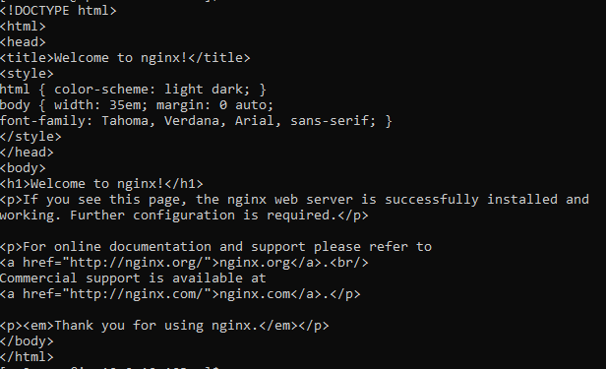
- task9_nginx_browser_page.png
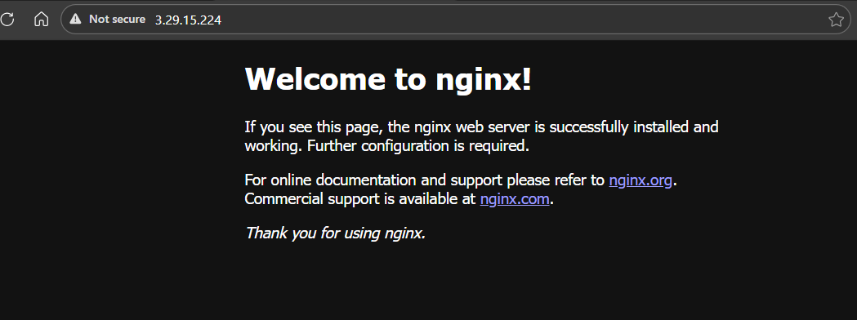

Cleanup
Objective: Destroy all Terraform-managed resources, verify state files, and ensure no sensitive files are committed.
Screenshots Required:
- cleanup_destroy.png
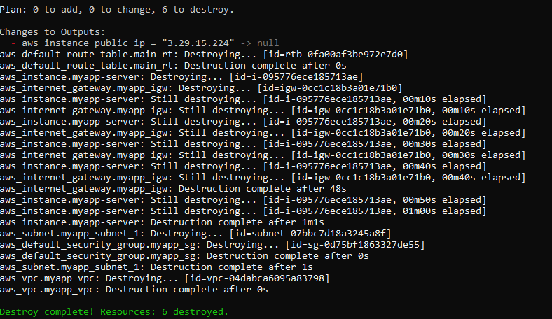
- cleanup_state_files.png
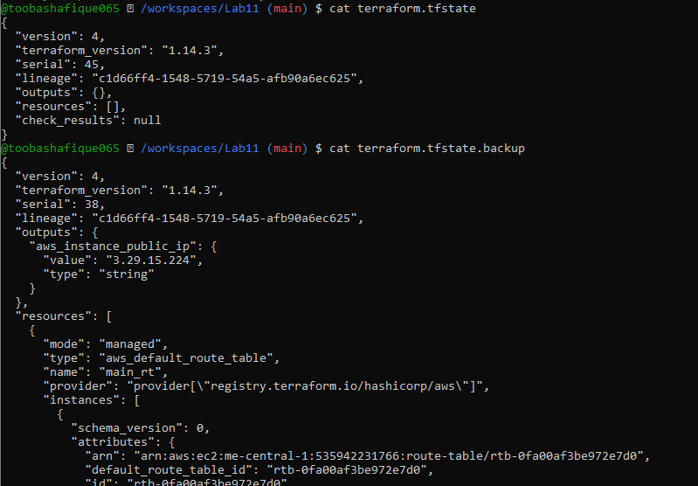
- cleanup_verify_no_secrets.png
